Nexora home dashboard
Document 4 of the Nexora learning guides
Source snapshot 14 October 2026 at 06:41 UTC
Understand the welcome screen, period selector, report cards and recent-record summaries.

Recognise the screen and its scope
Open /dashboard. CRM routes use port 3017; member routes use 3018; public website routes can use 3019. Brackets name a route parameter, not text to paste into a browser. Choose a real record or site id from the application.
This guide covers Welcome name; Report period; Permission-based datasets; Flip cards; Recent records and retry state.
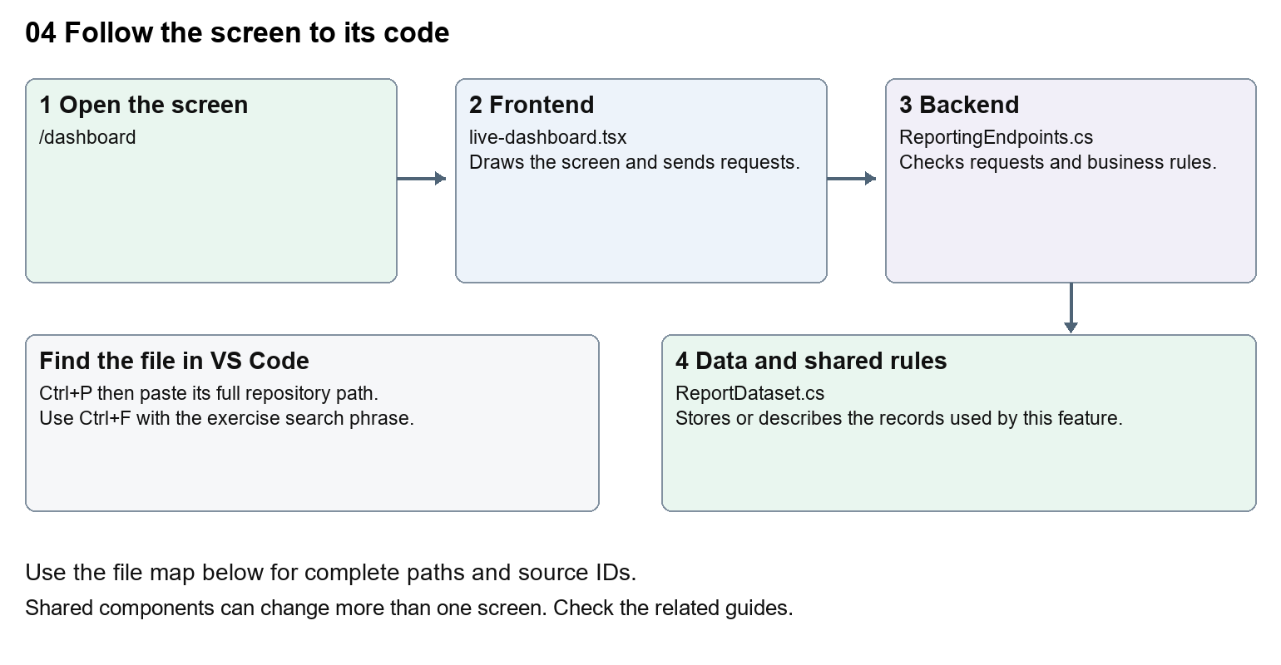
The diagram shows the file roles. The full paths below are what you paste into Ctrl+P.

Find the files in VS Code
Role | File and source ID | What it does
Screen | S0101 live-dashboard.tsx | Main UI or route for this topic
Server | S0578 ReportingEndpoints.cs | Endpoints or server rules
Data | S0200 ReportDataset.cs | Data shape or persistence structure

Screen S0101
apps/web/src/features/insights/live-dashboard.tsx
Server S0578
backend/src/Nexora.Api/ReportingEndpoints.cs
Data S0200
backend/src/BuildingBlocks/Nexora.BuildingBlocks/Reporting/ReportDataset.cs
The complete HTML manual opens these source IDs inside its Source library. The Word manual shows short labelled extracts so you can learn the flow before reading large files. Each individual Markdown guide includes its complete primary files after the walkthrough.

Follow the request and the records
1. The dashboard route checks the staff session.
2. LiveDashboard starts with its selected number of days.
3. It gets available datasets from /api/v1/insights/datasets.
4. It requests matching records for each dataset with fromUtc and toUtc.
5. Cards display totals and samples from those stored records.

Read the code with an explanation
The name comes from the session rather than a hardcoded person. useState stores the selected period in this mounted screen. useEffect loads data when the period changes; its active flag prevents a late response updating an unmounted screen. The counts describe records created in the period, not revenue or customer validation.
Source reference S0101 apps/web/src/features/insights/live-dashboard.tsx
Selected opening lines with their original numbers. The complete file is in the HTML source library.
0001 "use client";
0002 import { useEffect,useState } from "react";
0003 import { moduleApi } from "../shared/module-api";
0004 import { WorkspaceHeading } from "@/components/ui/workspace-heading";
0005 import styles from "./live-dashboard.module.css";
0006 type Row={id:string;label:string;status:string;createdAtUtc:string};

The import lines lead to shared components and helpers. Start at the exported component or route function; follow the request helper to the server rather than assuming the whole feature lives in this file.
Source reference S0578 backend/src/Nexora.Api/ReportingEndpoints.cs
Extract from source line 12. A fragment from a long line is shown without the rest of that line.
0012 api.MapGet("/datasets",(IEnumerable<IReportDataset> datasets,HttpContext http)=>datasets.Where(d=>Allowed(http,d)).Select(d=>new{d.Key,d.Title,fields=new[]{"label","status","createdAtUtc"}}));

On the server, look for MapGet to load records, MapPost to create or perform an action, MapPut or MapPatch to change data, and RequireAuthorization for permissions. Some shared methods register endpoints indirectly. Find SaveChangesAsync to see the database write. A request method alone does not tell you every side effect.
Source reference S0200 backend/src/BuildingBlocks/Nexora.BuildingBlocks/Reporting/ReportDataset.cs
Selected opening lines with their original numbers. The complete file is in the HTML source library.
0001 using Microsoft.EntityFrameworkCore;
0002 namespace Nexora.BuildingBlocks.Reporting;
0003 public sealed record ReportQuery(string? Search=null,string? Status=null,DateTime? FromUtc=null,DateTime? ToUtc=null,int Skip=0,int Take=50,string Sort="-createdAtUtc");
0005 public sealed record ReportPage(int Total,IReadOnlyList<ReportRow> Items);
0006 public interface IReportDataset
0007 {

Follow model fields to their request names and database mapping. An id points to a particular record. A tenant id limits the organisation. A version or concurrency stamp protects newer edits. Some model files describe contracts rather than tables; check the owning DbContext before assuming storage.

Make or trace your first change
1. Press Ctrl+P and open apps/web/src/features/insights/live-dashboard.tsx.
2. Press Ctrl+F and search for Stored records created during the selected period.. In this snapshot it appears at line 11.
3. Replace only this explanatory sentence. Reload /dashboard and change the period. Check that card loading and totals still work.
4. Replace only Stored records created during the selected period. with Records created in your chosen period. in that intended location. Keep quotes, tags, JSON keys and routes intact.
5. Save with Ctrl+S. Inspect Problems and the local screen. Review the diff and restore the original text when you finish practising.
Extract from source line 11. A fragment from a long line is shown without the rest of that line.
0011 lassName="mt-2 text-sm text-white">Stored records created during the selected period.</p></div><label className="text-sm">Report p

These exercises have not been applied to the application. Their search phrases are verified against the captured source. Line numbers can move; the phrase and file path are your main navigation aids.

Check a change and diagnose problems
Confirm the original screen still loads, the changed words appear in the intended place, and another screen using the same component still behaves correctly. If an action fails, inspect the browser Network response, the relevant helper and server validation message. Use the common error table at the beginning of the manual. Reload on a version conflict instead of removing the version check.
A syntax error after a text edit usually means a quote, brace or closing tag changed. Compare your diff with the original. An unchanged browser result can mean the wrong port, a saved published configuration overriding a default, or a running API that has not reloaded.

Understand the current limits
The user needs reporting permission. The reporting service also filters datasets by module permissions and tenant. Counts are a point-in-time result; no automatic real-time stream is implied.

Continue learning
Related guides 19 Nexora insights and reporting, 20 Nexora administration and access.

